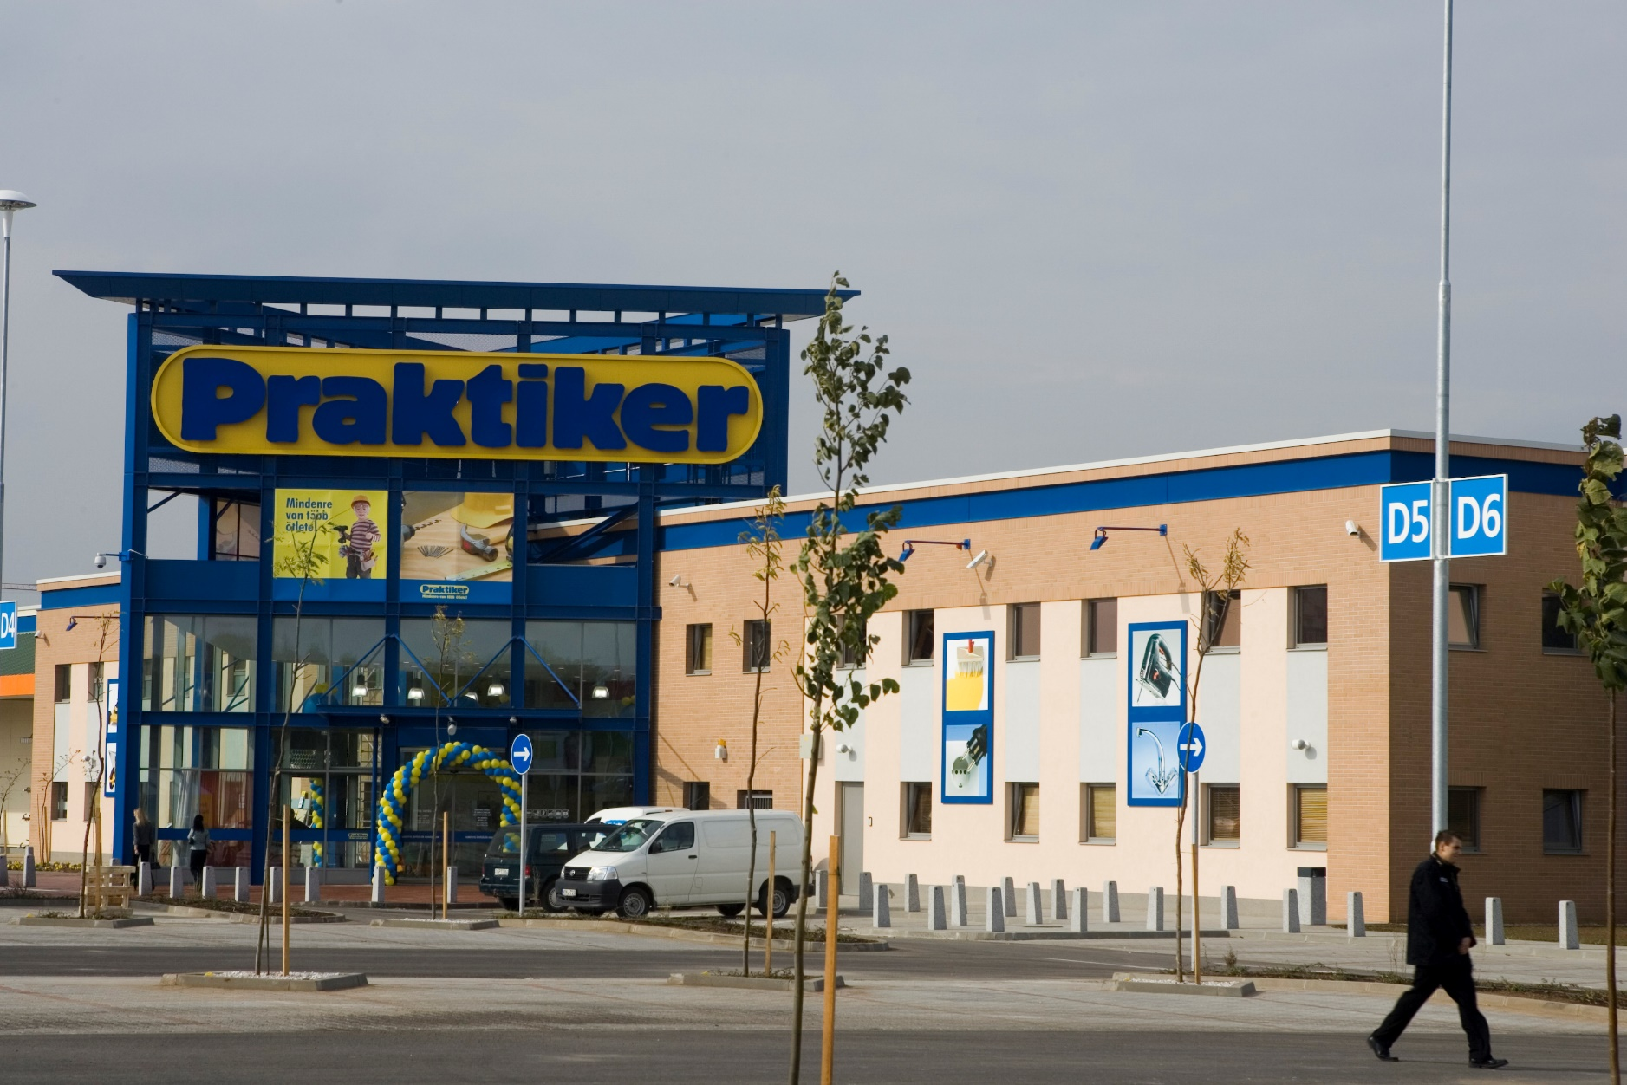

**Demand Forecasting**

**Case Study**



**Praktiker, a Central European DIY retailer, centralized replenishment** to streamline business processes, improve efficiency and scale.

Moving away from previous forecasting solutions and providers, **Praktiker** **leveraged Blue Sky’s demand forecasting service** to provide reliable decision support in its merchandising team.

Blue Sky’s demand forecasting service was **initialized and launched in 6 weeks**.

**Benefits** include

* **400% growth in efficiency** of managing ordering and replenishment for all stores and ecommerce
* **5% service level improvement**: inventory structure improved significantly, driving up to 5% potential improvement in revenue (fewer stock outs and overstocks)
* **15% forecast accuracy improvement:** compared with accuracy of previous forecasting solutions
* **Ongoing weekly improvement** in intelligence and accuracy of forecasts during ongoing service delivery via recommendation of increasing input variables and continuously evolving correlational insights made by AI.



**Praktiker CFO  
Dr. Sándor Ónody**

© 2021 Blue Sky Retail Solutions LLC [www.blueskygrs.com](http://www.blueskygrs.com) [sales@blueskygrs.com](mailto:sales@blueskygrs.com)

*“We have chosen Blue Sky’s team of experts because of their* ***proven international and global retail know-how, best practice and data science expertise*** *delivered with a high degree of professionalism. Blue Sky’s solution portfolio also includes additional features that are interesting for us such as price optimization.”*